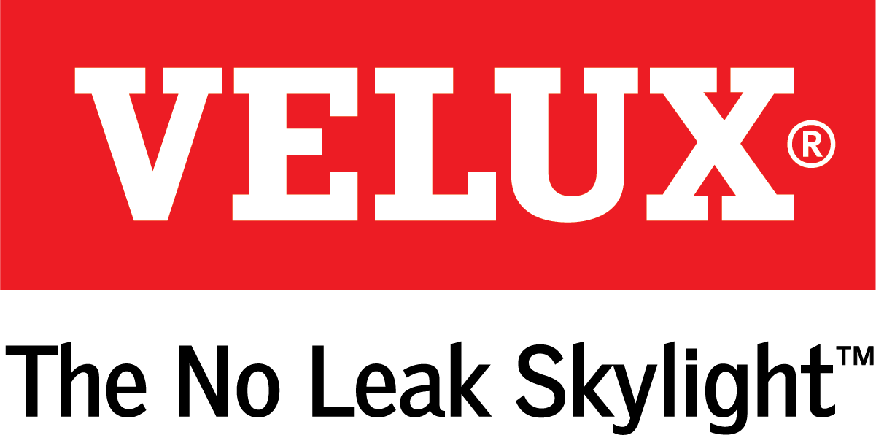
Media Contacts:
Kelsey Webb
704-790-1560
kwebb@wrayward.com

Dana Haydock
704-926-1301
dhaydock@wrayward.com

VELUX ACTIVE WITH NETATMO SKYLIGHT AUTOMATION SYSTEM NOW COMPATIBLE WITH GOOGLE ASSISTANT

Smart Technology Combats Poor Indoor Air Quality

LAS VEGAS, Jan. 21-23, 2020 – VELUX ACTIVE with NETATMO, the smartphone-controlled skylight automation system, is now compatible with Google Assistant. The system allows homeowners to easily and effortlessly achieve a healthier indoor climate in their homes by automating when their skylights open and close to create air flow and when skylight blinds extend for light control. Americans continue to have growing interest in smart home technology and home health. According to research from the Harvard University Joint Center for Housing, nearly a quarter of homeowners have healthy home concerns¹ with worries about indoor air quality topping their list.
“Many people are unaware that indoor air can be five times more polluted than outdoor air,” said Ross Vandermark, national product manager for VELUX America. “Having options like VELUX ACTIVE to take the thinking out of indoor air quality is a welcomed addition for homeowners wanting to maintain healthy homes for themselves and their families.”
People are now spending on average 90% of their time indoors², and since homes are built tighter allowing for less air exchange from the outside, they are often breathing air polluted by everyday activities like cooking, cleaning and bathing. VELUX ACTIVE helps to refresh indoor air by automating when skylights open, combatting negative side effects of an indoor lifestyle, such as asthma and allergies.
The system connects to an online weather station to monitor outside conditions and uses indoor sensors to monitor temperature, humidity and CO2 levels inside the home. Based on homeowner settings, the system will open the skylights or extend the blinds if doing so improves the conditions inside the home. For example, if the humidity level inside rises above the homeowners’ decided preferences, and it is less humid outside, the system will open the skylights for a short period of time to refresh the air inside. Likewise, the system may also extend the skylight blinds to block light when the outside temperature is high.
With Google Assistant, homeowners can voice operate their skylights by simply saying “Hey Google, open my skylights,” or “Hey Google, close my skylight blinds.”
They can also set up a schedule for their skylights and blinds to open and close. A rain sensor ensures the skylights close at the first sign of rain.
VELUX ACTIVE is also compatible with Apple® HomeKit. Homeowners can use the VELUX ACTIVE smartphone app to control their skylights even if they are away from the house. For more information on VELUX ACTIVE, visit www.veluxusa.com.

# # #

VELUX is the world leader in skylights and roof windows and is one of the strongest brands in the global building materials sector. VELUX products are available nationwide through home centers, building material suppliers, lumberyards and independent door, window or roofing retailers. Consumers can locate local suppliers and installers and access information on skylight selection and the benefits of bringing more natural light and fresh air into the home by visiting www.veluxusa.com or www.whyskylights.com. VELUX skylights are made in America in Greenwood, South Carolina.

1) Healthy Home Remodeling: Consumer Trends and Contractor Preparedness, January 2019
2) U.S. Environmental Protection Agency- Report to Congress on indoor air quality- Volume 2

